Er RAJAT KALIA
(B.TECH IIT-Delhi)
PH. 9815439805
Er MANISH KALIA
B.TECH (Delhi COLLEGE OF ENGINEERING)
PH. 09990074601,9878146388

9DE

Binomial Theoram is one chapter in which you see a question and then realise that it can easily be done in 2 or 3 ways. Definitely one of the most interesting chapters which uses concepts from calculus, trignometry, complex number prognessiong and wkhat not Binomial theoram finds use in number theory as well. So, let us prober deeper into this section.
Binomial theorm
Definition of Bionomial theoram
If n is a +ve integer and x₁ y are 2 complex number then .
(x + y)^{n} ^{n} C_{r} x^{n-r} y^{r}
= ^{n}C_{o}X^{n} - ^{n}C₁ X^{n-1} y + ^{n}C₂ X^{n-2} y² +............+ ^{n} C_{n} y^{n}
Similarly (x - y) ^{n} = ^{n}CoX^{n} - ^{n}C₁ X^{n-1} y + ^{n}C₂ X^{n-2} y² +.......+ (-1) ^{n} ^{n} C_{n} y^{n}
The oefficients ^{n} C_{o}, ^{n}C₁, .................^{n}C_{n} are called Bionomial coeff.
Some important facts
(i) There are (n + 1) tevms in the expression .
(ii) lthe sum of in dices. Of x and y in each term of expansion is n .
(iii) The bionomial 3efficent of the terms equidistant from begining and the end are equal .
(iv) The r-th term from end in (x + y)^{n} = (h + r + 2) th term from beginning .
General term.
In the expansion of (x + y)^{n} the (r + 1^{tn}) term from beginning of expansion is
Tr + 1 = ^{n}C_{r} a^{n-r} b^{b}
Illustration 1
Expand 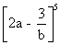by biobomial theoram .
Ans:- Using bionomial theoram we get
= 32 a⁵ - 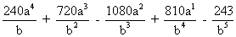
Illustration 2.
If the ratio of 7th term from beginning to the seventh term from the end in the expassion of 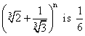then what is n .
Ans T₇ from end of (a + b)^{n} is same as T₇ from beginning of (b + a)^{n}
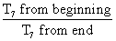of (a + b)^{n}
or 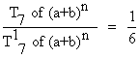
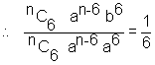
or 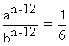
or ( 2 ^{1/3} 3 ^{1/3} ) ^{n - 12} =
=> 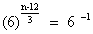
or 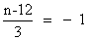
So, n = 9

Greates Binomial coefficient(or Middle terms)
(1) If n is even, then there is only one middle term which (h/2 + 1) ^{th} term i.e.
T_{n/2} + 1 = ^{n} C_{n/2} X ^{n/2}
and ^{n}C_{n/2} is greatest bionomial coefficient
(2) If n is each them trere are two middle terms which are 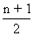^{th} and 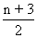^{th} terms i.e
=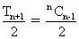 a ^{(n+1)/2} b^{(n-1)/2}
and 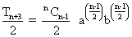
And, 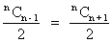are greatest bionoimial ccoefficients
Numarically Greatest term of Bionmial expansion
(a + x)^{n} = Co a^{n} + C₁ a^{n-1} x.........+ C_{n-1}ax^{n-1} + C_{n}x^{n}.
The numerically greatest term will be T_{r+1} where r = ....
If 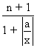itself is a natural number then T_{r} = T_{r+1}
both are numerically greatest terms.
Why ?
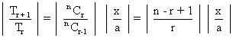
If 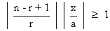for given a, x and n
then 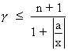
So, when 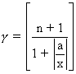
Illustration 3
Show that middle term in the expansion of (1 + x)^{2n} is img........... where n isa +ve integer.
Ans This number of terms in expassion of (1 + x)^{2n} is 2n + 1 (odd)
So, its middle term is (n + 1)^{th} term.
Required Term = T_{n+1} = ^{2n} C_{n} x^{n}
= 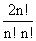x^{n}
= 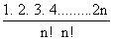x^{n}
= 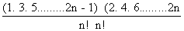x^{n}.
= 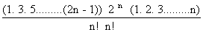x^{n}
= 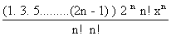
= 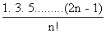2^{n} x^{n}
Illustration 4
find the greatest term in the expansion of 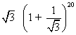
Ans Let us find r = 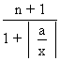
So, r = 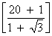
= 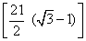
= 7
T_{r+1} = T₈ is greatest term
Now T₈ = ²⁰ C₇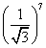
= 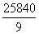
Summation of series of Bionomial co-efficients.
Series of Bionomia cofficients cn be umme by uing methods like by taaking prouct o expnion of two bionomial by differentiating bionomial expansion, integraating bionomial expansion by equating real and imaginory part of a eries etc.
(1) Sum of sevies by taking product o expnsions of two bionomials if we find the product of binomial coefficients in tnhe sevies then this method can be used .

Illustration 5
Prove that C₀² + C₁² + C₂²+..............C_{n}² =
Ans : We know .
(1 + x)^{n} = C₀+ C₁ C₂ x².......+C_{n-1}x^{n-1} + C_{n}x^{n}
Also. (x + 1)^{n} = C₀ x^{n} + C₁ x^{n-1} + C₂ x^{n-2}+........... + C_{n-1}x + C_{n}
Now Let us multiply the two expansions and compare the coefficient of x^{n} on both side .
(1 + x)^{n} (x - 1)^{n} = (C₀ + C₁ x + C₂ x² ........+C_{n}x + x^{n}) X
(C₀ x^{n} + C₁ x^{n-1} + C₂ x^{n-2}+........... + C_{n-1}x + C_{n} )
Coefficient of x^{n} in (1 + n)^{n} (1 + n)^{n}
=> Coeff. of x^{n} in (1 + x)^{2n}
= 2n_{Cn}
Coeff. of x^{n} in ( C₀ + C₁ x+ C₂ x² +......C_{n} x^{n} ) X
(C₀x^{n} + C₁x^{n} + ..........+C_{n})
= C₀² + C₁ ² + C₂²+............+ C_{n-1}² + C_{n}²
C₀² + C₁ ² + C₂²+............+ C_{n-1}² + C_{n}²
So, Comparing the coefficients un the 2 sidse we get .
C₀² + C₁² + C₂²+............+ C_{n-1}² + C_{n}²= 2n _{Cn}
=
(2) Sum of sevies by use of differentiation:
When numericals occur as product of bionomial Coefficients this method is used .
Illustration 6
Find thesum of the following sevies.
C₀ + 2C₁ + 3C₂ +...............+ (n + 1) C_{n}?
Ans We know that
(1 + x)^{n} = C₀ + C₁x +C₂ x² + ..................+C_{n} x^{n}
So, Multiplying both sides with x we get
x(1 + x)^{n} = C₀ x + C₁ x² + C₂ x³ + ........+C_{n} x ^{n+1}
Now differentiating both sides with respect x we get
xn(1 + x)^{n-1} + (1 + x)^{n} = C₀ + 2C₁x + 3c₂ x²+...........+(n + 1) C_{n} x^{n}
Now put x = 1
So, n 2^{n-1} + 2^{n} = C₀ + 2c₁ + 3C₂+...........+ (n + 1)C_{n}
So, C₀ + 2c₁ + 3C₂+...........+(n + 1)C_{n} = (n + 2)2^{n-1}
Dumb Question:- Why did we multiplied binomial expansion with x initially ?
Ans Observe that the numerical with binomial coefficients were one more in value that the corresponding power of x, So we needed to multiply the expansion by x.
(3) Sum of series by use of integration
When numerical occur as the denominator of the binomial Coefficient we apply this method.
Illustration 7.
Find the sum of series 2C_{o} + 2 ² 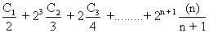
And
We know
(1 + x) ^{n} = C₀ + C₁ x + C₂ x² +..........+ C_{n}x^{n}
Integrating both sides with respect to x we get
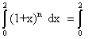(C₀ + C₁ x + C₂ x² +..........+ C_{n}x^{n) dx}
=> 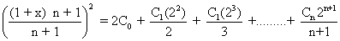
2C_{o} + 2² 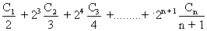
= 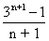
(4) Sum of the series by equation real and imaginary parts.
Sometimes the use of complex nos make the calculation very easy

Illustration 8
If (3 + 4x)^{n} = P₀+ P₁x + P₂x² +...+ P_{n}x^{n} then prove that (P_{o} - P₂ + P₄...)² + (P₁ - P₃+ P₅ ....)² = 25^{n}
Ans . Let us put x = i in the expansion
(3 + 4x)^{n} = P_{o}+ P₁x + P₂ x² +.............+P_{n}x^{n}
So, we get
(3 + 4i)^{n} = (P_{o} + P₂ + P₄ ...........) + i (P₁ -P₃ + P₅ ...............)
Now equating the square of the modulus, we get
(P_{o} + P₂ + P₄ ...........) ²+ (P₁ -P₃ + P₅ ...............)²
= (3²+ 4²) ^{n}
= 25 ^{n}
Dumb Question Why did P₄ got a +ve sign in front of it ?
Ans P₄ is Coefficient of x⁴ . So,when we put i. i⁴ gives the sign and .
i⁴ = (i²)² = (-1)² = 1
Binomial Series (for negative or fractional indices)
If and | x | < 1, then
(1 + x)^{n} = 1 + nx + 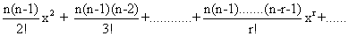
General term = T _{r+1} 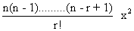
Illustration 9
Find the coefficients of x⁴andx⁻⁴ in expansion of
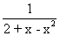, | < x < 2 .
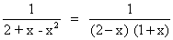
=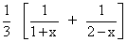
=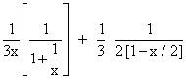
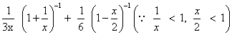
= 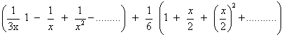
Coefficient of x⁴ = 0 + 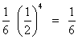
Coefficient of x⁻⁴ = 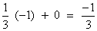
Binomial Theoram
If n is a positive integer then
( a₁ + a₂ + ........+ a_{m}) ^{n}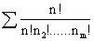 a₁^{n1}a₂^{n2}. a₃^{n3}.......a_{m} ^{nm}
Where the summation is taken over all non-negative integers n₁, n₂ ..........n_{m} such that n₁+ n₂ + n₃+.....+ n_{m} = n
and the number of terms in the expansion is
= number of non-negative integral sol^{n} of equation
n₁ + n₂ +..........+n_{m}
= ^{n + m -1} C_{m-1}
Illustration 10 .
find the total number of terms in the kexpansion
of (x + y + z + w) ^{n}
Ans. From Hultinomial Theorm
(x + y + z +w )^{n} = 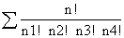x₁^{n1} y ^{n2} z^{n3} w^{n4}
where n₁, n₂, n₃, n₄ are non negative integers subject to the condition n₁ + n₂ + n₃ + n₄ = n
Hence no of distinct terms
= Coefficient of x^{n}in (xº + x¹ + x² +.......+x^{n})⁴
= Coefficient of x^{n} in 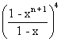
= Coefficient of x ^{n}in (1 - x^{n+1})⁴ (1 - x)⁻¹
= Coefficient of x ^{n}in (1 - x)⁻⁴ (since x^{n+1}
= n + 3_{Cn}
= 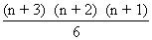
Dumb Question Why is no of disfinft terms equal to coefficient
of x^{n} in (xº + x¹ + x²+....................+x^{n} )⁴ ?
Ans This is actually a problem of permutation and combipnation
But Let us discuss it here very brifly .
Equation is n₁ + n₂ + n₃ + n₄ = n
Now n₁ can vary from o to n
Similar is the case for n₂, n₃ and n₄.
So, xº + x¹ + x² +..................+ x^{n} for n₁
and (xº + x¹ + x² +..................+ x)⁴ for all n₁, n₂ + n₃ and n₄.
And then we try to find coeft of x^{n} as n₁ n₂+ n₃ + n₄ head to sum to n
Easy
(1)Prove that C_{o} + C₁ + C₂+..........C_{n} = 2^{n}
Ans we know
C_{o} + C₁ + C₂+..........C_{n}x^{n} = (1 + x) ^{n}
Now put x = 1 or both sides
C_{o} + C₁ + C₂+..........C_{n} = 2^{n}
(2) find the sum kof series 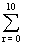^{20 C}_{r} ?
Ans We know = 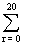²⁰ C_{r} = 2²⁰
Now L.H.S. mhas 21lterms out of which 10 pairs are equal.
because ^{n}C_{r}= ^{n}C_{n - r}
So, L.H.S. 2 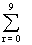²⁰ C_{r} - ²⁰ C₁₀ = 2²⁰
So, 2 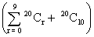= 2 ²⁰ + ²⁰ C₁₀
or 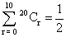(2 ²⁰ + ²⁰ C₁₀)

(3) Find the digit at unit place in the number .
16 ¹⁹⁸⁶ + 11¹⁹⁸⁶ - 6¹⁹⁸⁶. ?
And Let E = 16 ¹⁹⁸⁶ + 11¹⁹⁸⁶ - 6¹⁹⁸⁶
So, E = (10 + 6)^{n} + (1 + 10)^{n} - 6 ^{n}
where N = 1986
= 10^{N} + ^{N} C₁ 10^{N-1} 6 + ..........+ ^{N}C_{N-1} 10. 6^{n-1} + 6^{N}
+ 1 + ^{N} C₁ 10. + ^{N} C₂ 10² + .........+ ^{N} C_{N}10 ^{N} - 6^{N}
= 1 + All inteqers being multiple of 10
So, The digit at unit place is 1.
(4) Find the value of x for which the sixth term of 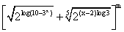is equal to 21 and binomial coefficient of second, third and fourth terms are first, third and fifth terms of an aritnmetic progression .
Ans The sixth term of the given binomial exponsion is
^{m}C₅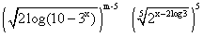 ..................(1)
The other given lcondition is, m_{C1} + m_{C3} = 2 m_{C2}
=> m² - 9m + +14 = 0 => (m - 7) (m - 2) = 0
or m = 7 Since m = 2 is not possible .
Put m = 7 in equation (1) to get x = 0, 2
Dumb Question Why m cannot be 2 ?
If m = 2 then there cannot be 6th term in the expansion and hence it is ruled out .
If n is any positive integer show that . 2^{3n+3} - 7n - 8 is divisible by 49 ?
The given expression
= 2^{3n+3} - 7n - 8
= 2^{3(n+1)} - 7n - 8
= 8 ^{n+1} - 7n - 8
=(1 + 2)^{n+1} - 7n - 8
= 8 (1 + 7) ^{n}- 7n - 8
= 8 (1 + ^{n}C₁ 7 + ^{n} C₂. 7²........^{n}C_{n} 7^{n} ) - 7_{n} - 8
= 8 + 56_{n} + 8 (^{n}C₂ 7² ........+ ^{n} C_{n} 7 ^{n} ) - 7_{n}- 8
= 49 _{n} 8 (^{n} C₂ 7² +..............+ ^{n} C_{n 7}^{n} )
= 49 (n + 8 ( ^{n} C₂ + .......+ ^{n} C_{n} 7 ^{n-2} ) )
So, 2^{3n+3} - 7_{n} - 8 is divisible by 49 .
(6) Find the coefficient of x ⁵⁰ in the polynoamial
(1 + x) + 2(1 + x)² + 3(1 + x)³+.........+1000 (1 + x) ¹⁰⁰⁰ ?
Ans Let P(x) = (1 + x) + 2(1 + x)² + 3(1 + x)³+.........+1000 (1 + x) ¹⁰⁰⁰
Now (1 + x) p(x) - P(x)
= (1 + x)² + 2(1 + x)³ + 3(1 + x)⁴ +.........+999 (1 + x) ¹⁰⁰⁰+ 1000(1 + x) ¹⁰⁰⁰
- (1 + x) - 2 (1 + x)² - 3 (1 + x)³ ....................- 1000 (1 + x)¹⁰⁰⁰
= 1000 (1 + x)¹⁰⁰¹ - (1 + x) - (1 + x)² - (1 + x)³-.................-(1 + x)¹⁰⁰⁰
1000 (1 + x) ¹⁰⁰¹ - [ (1 + x)- (1 + x)² +.........+ (1 + x)¹⁰⁰⁰]
= 1000 (1 + x)¹⁰⁰¹- 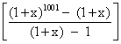
= 1000 (1 + x) ¹⁰⁰¹ - 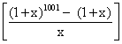
= P(x) = 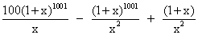
So, coefficient of x⁵⁰ in P(x)
= 1000 X ¹⁰⁰⁰ C₅₁ = ¹⁰⁰⁰C₅₂
= 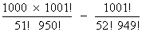
= 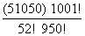
(7) If (1 + x )^{n} = a_{o} + a₁x + a₂x²+ ..........+a_{n} x^{n} then find
value of 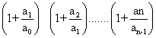?
Ans Clearly a_{r} = ^{n} C_{r}
So,
=> 1 + 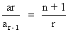
So, 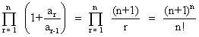
Sum the following series
C_{o} + 5c₁ + ac₂ + ac₂+.........................+(4n + 1)c_{n}
Ans Let S = C_{o} + 5c₁ + ac₂ + ac₂+.........................+(4n + 1)c_{n}............(1)
Sine C_{r} = C_{n} -r
So, S C_{n} + 5C_{n-1} + ª C_{n} +.............+ (4n = 1)C_{o}
or S = (4n + 1) C_{o} + (4n - 3) C₁+..................+5C_{n-1}+c_{n}......(2) Now Adding (i) + (2) we get
25 = (4n + 2) C_{o} + C₁ +............C_{n} )
=> S = (2n + 1) 2^{n}
So, C_{o} + 5C₁ + 9C₂ + ........+ (4n + 1) C_{n} = (2n + 1) 2^{n}

(9) If is an odd natural lnumber then what is the value
Of 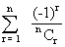?
Ans Since n is odd, the number of terms will be n + 1 which is even, Now since 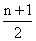is an integer we make pairs of terms equidistant from the beginning and end .
So, 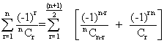
(-1) ^{r} 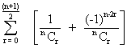
(-1) ^{r}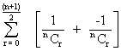 = 0
f
Hence 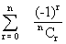= 0
Dumb Question : Why (-1) ^{n-2r} is -1 for all v )
Ans Since n is odd so, n - 2r is odd as 2r is even .
Thus (-1) ^{odd} = -1 .
(10) find the sum of the series .
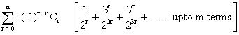
Ans 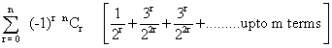
= 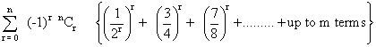
= 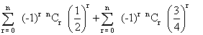+............up to m terms
= 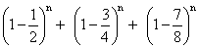
=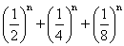
= 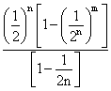
= 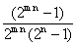
(11) Prove the following identity
^{n} C_{o} + ^{n+1} C₁ + ^{n+2} C₂+...........+^{n+r} C_{r} = ^{n+r+1} C_{r}
Ans ^{n} C_{o} is coefficient of x^{n} in expansion of (x + 1)^{n}
^{n+1} C₁ is coefficient of x^{n} in expansion of (x + 1)^{n+1}
....................................................................
^{n+r} C_{r} is coefficient of (x + 1) ^{n+r}
Thus L.H.S. is coefficient of x^{n} inexpansion of
(x + 1)^{n} + (x + 1)^{n+1} +................+ (x + 1)^{n+r}
Or coefficient of x^{n} in (x + 1) ^{n} 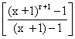
Or coefficient of x^{n} in 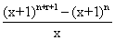
Or coefficient of x^{n+1} in (x + 1)^{n+r+1} - (x - 1) ^{n}
=^{n+r+1} c_{n+1} (since (x + 1)^{n} has no ten containing x ^{n+1} )
= ^{n+r+1}C_{r}
Medium.
(1) Given that 4th term in expansion of 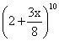has the maximum numberical value, find the range of value of x for which this will be true .
Ans According to the question
| t₄ | | t₃ |, | t₄ | | t₅ |
Now, t_{r+1} = ¹⁰C_{r}2^{10-r} 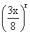
t₄ = ¹⁰ C₃ 2⁷ 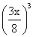
t ₃ = ¹⁰ C₂ 2⁸ 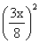
and t₅ =¹⁰ C₂ 2⁶ 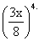
Now, | t₄ | | t₃ |
=> ¹⁰ C₃ 2⁷ 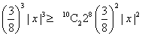
=> | x | 2 ...........(1)
and | t₄ | | t₅ |
¹⁰C₃ 2⁷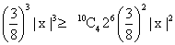
=> 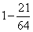| x | 0 .............(2)
Clearly 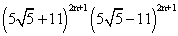
= 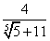
is a positive proper fraction
and so g = 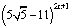is also a positive proper fraction.
Thus, 0 < f < 1 and 0 < g < 1
Now, [R] + f - g
= 2
= 2 X inteqer = even integer.
f - g must be an integer because [R] is ans itneger .
Now f - g = 0 i.e f = g .
R. F{ [R] + f } = ( [R] + f ) g
=
=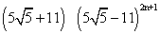
= 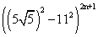
= 4 ^{2n + 1}
Dumb Question.
Why f - g is zero ?
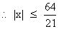
Thus we get | x | 2 and | x | 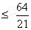
So, x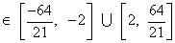

Dumb Question
Why we had an interval 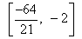in answer ?
Ans . Well we have the situation
| x | 2 and
So, | x | 2 means
x 2 or x - 2
Similariey | x |
and hence we get the interal 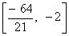
(2) Let R = 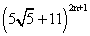and F = R - [R] where [] denotes the greatest integral funftion. Prove that RF = 4^{2n+1}.
Ans R = [R] + F =
= ^{2n+1}C_{o} 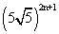+ ^{2n+1}C₁ 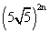. 11 +............+ ^{2n+1}C_{2n+1} 11^{2n+1} .....................(1)
Let g = 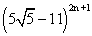
= ^{2n+1} C_{o} - ^{2n+1} C₁11 +............+ ^{2n+1}C_{2n+1} 11^{2n+1} .....................(2)
F and g both are positive proper fraction. i.e.
O < f < 1, O< g < 1
So, F - g con not be any integer exept zero because where both f and g not kintegers how can there difference be.
(3) If (1 + x + x²)^{n} = a_{o} + a₁x + a₂x² + a₃ x³ +........+ a_{2n}x
^{2n} then show that
a_{o} + a₃ + a₆ +..........=a₁ + a₄ + a₇ +.............
= a₂ + a₅ + a₈ + .....................
Ans Putting x = 1, w, w² where w is a non ,real cine root of unity ?
So, Z^{n} = a_{o} + a₁ + a₂ +..................................(1)
O = a₀+ a₁ w + a₂ w²+ ..............( + w + w² = o ) .......(2)
0 = a₀ + a₁ w² + a₂ w⁴ ...............( 1 + w + w² = 0 ) ...........(3)
Adding these .
3^{n} 3 a₀ + a₁ (1 + w + w²) + a₂ (1 + w + w⁴ ) + a₃ (1 + w³+ w⁶) + .........
= 3(a₀ + a₃ + a₆ +................)
=>a₀ + a₃ + a₆ + ...........3^{n-1}
from (1) + (2) X w² + (3) X w.......we get
3^{n} + O X w² + O X W
= a₀ (1 + w² + w ) + a₁ (1 +w³+ w³ ) + a₂ (1 + w⁴ + w⁵ + a₃ (1+ w⁵ + w⁷) + a₄ (1 + w⁶ + w⁹ ) +.........
img..........3^{n} = 3(a₁ + a₄ + a₇ + ..............)
So, a₁ + a₄ + a₇ + .................3^{n-1}
Again from (1) + (2) x w + (3) w² we get
3^{n} = a₀ (1 + w + w² ) + a₁ (1 + w² + w⁴ ) +a₂ (1 + w ³ + w³ ) +.........
= 3(a₂+ a₅ a₈+..........)
a₂ + a₅ + a₈ +..............=3^{n-1}
Dumb Question.
Why 1 + w⁴ +w⁵ is equal to zero and
1 + w⁶ +w⁹ is 3.?
1 + w⁴ +w⁵ = 1 + w +w² (using w³ = 1 )
= 0
Also 1 + w⁶ +w⁹ = 1 + (w³) ² + (w³) ³
= 1 + 1 + 1
= 3 .
(4) Find the value of C₀ - C₁ 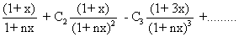
Ans . Let C_{o} - C₁
= 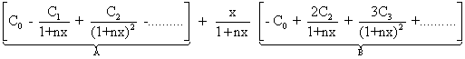
So, (1 - y)^{n} = C₀ - C₁ y + C₂y² - C₃ y³ +........(-1)^{n} y^{n}
defferentiating w.r.t. y we get
-n (1 - y)^{n-1} = - C₁ + 2C₂ y - 3C₃ y² +............
Now A = 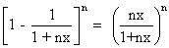
and B = -C₂ + 2C₂ 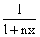
= - n 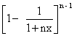
= - n 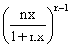
So, C₀ - C₁ 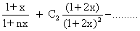
= A + 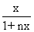B
= 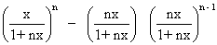
= 0
(5) Prov that 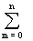^{n} C_{m} sin (mx) cos ((n-m)x) = 2^{n-1} sin <(nx)
Ans ^{n} C_{m} sin (mx) cos (n - m) x.
= ^{n} C₀ (0.x ) cos nx + ^{n}C₁ sin x ccos (n -1) x
=^{n} C₂ sin 2x cos (n - 2) x + .................
.................= ^{n} C_{n} sin nx cos (0 . x)
=> 2 ^{n} C_{m} sin (m x) cos (n - m) x
[ ^{n} C₀ (0 . x) cos nx + ^{n} sin nx cos 0 . x]
+ [ ^{n} C₁ sin x cos (n - 1) x + ^{n} C_{n-1} sin (n - 1) x . cos x ]
......+ [^{n} C_{n} sin nx cos(0 . x) + ^{n}C₀ sin (0 . x) cos nx ]
Using ^{n} C_{r} = ^{n} C_{n-r} we get
2 ^{n} C_{m} sin (m x) cos (n - m ) x
= ^{n} C₀ [ sin (0 . x) cos (n x) + sin (n x) cos (0 . x)]
+ ^{n} C₁ [ sin x cos (n -1) x + sin (n - 1) x cosx ] + .......
...........+ ^{n} C_{n}[ sin x cos (0 . x) + cos (n x )sin (0 . x)]
NOw using sin (A + B) = sinA cos B + cosA sinB we get
( ^{n} C₀ + ^{n} C₁ + ^{n} C₂ +.................+^{n} C_{n} ) sin nx = 2^{n} sin nx.
So, ^{n} C_{m} sin (m x) cos (n - m) x = 2^{n-1} sin (nx)
(6) If a_{n} = 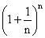then prove that 2 < a_{n} < 3 img......

Also show that
n^{n-1} > (n + 1)^{n} ; 3 ,
Ans . We get a_{n} =
= 1 + n 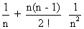+ .....................
= 1 + 1 + 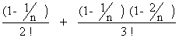+ ..............
= 2 + Positive quantity
a_{n} > 2 . ...............(1)
Alos, a_{n} < 1 + 1 + 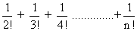
< 1 + 1 +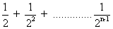
< 1 +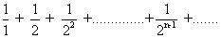
< 1 + 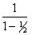
< 3 ...................(2)
From (1) and (2) we get
2 < a_{n} < 3
So, a_{n} < 3
Or < 3
or < n ( n 3 )
or..........img
So, (1 + )^{n} < n⁴. n
or (n + 1)^{n} < n^{n+1}
Dumb Question
Why img..........
img............
Ans We are dividing one by a smaller no because all natural no.s except 2 are bigger than 2 only
So, 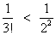
as 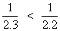
3 > 2 so,
For other factor also
So, 1 + 1 + 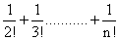is less than 1 + 1 + 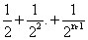
Hard
(1) Prove that (-1 ) ^{r-1 3n} C_{2r-1} = 0 where k=
is an even positive inteqer.
Ans Given n is an even positive inteqer.
Let n = 2m R = 3m
L.H.S. (-3)^{r-1} ^{3n}C _{2r-1} = (-3) ^{r-1} ^{6m} C_{2r-1}
= ^{6m} C₁ - 3 ^{6m} C₃ + 3² ^{6m} C₅-........+ (-3)^{3m-16m} C_{6m} -1 ..........(1)
(1 + i ) ^{6m} = ^{6m} C_{o} + ^{6m} C₁ (i ) + ^{6m} C₂ (i )²+ .........+ ^{6m}C_{6m-1}(i ) ^{6m-1}+ ^{6m} C_{6m}(i )^{6m}img ................
or 2^{6m} 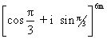=6m C_{o} + ^{6m} C₁ (i ) + ^{6m} C₂ (i )²+ .........+ ^{6m}C_{6m-1}(i ) ^{6m-1}+ ^{6m} C_{6m}(i )^{6m}
or 2^{6m}( cos 2 + i sin 2 m )
=( ^{6m}C_{o} - 3 ^{6m} C₂ + 3² ^{6m} - .....+ (-3) ^{3m} ^{6m} C_{6m}) + i ( ^{6m}C_{o} - 3 ^{6m} C₂ + 3² ^{6m} - .....+ (-3) ^{3m} ^{6m} C_{6m})
Companing imaqinary part on both sides we get .
( ^{6m} C₁ - 3 ^{6m} C₃ +3² ^{6m}C₅...........+ (-3) ^{3m-1 6m}C_{6m-1} ) = 0
Or ( ^{6m} C₁ - 3 ^{6m} C₃ +3² ^{6m}C₅...........+ (-3) ^{3m-1 6m}C_{6m-1} ) = 0
=> (-3) ^{r-1} ^{6m} C_{2r-2} = 0
Or (-33) ^{r-1} ^{3n} C_{2r-1} = 0 (where n = 2m)
Dumb Question: How did ( cos + i sin ) ^{6m} be came cos 2 m + i sin2m ?
inmg........
Ans We used Eulers Rule which is (( cos + sin ) ^{m} = cosm +sin
So, ( cos + i sin ) ^{6m} = cos ^{6m}+ i sin ^{6m})
= cos 2m + i sin 2m

(2) If n > 3 then prove that
C₀ ab - C₁(a - 1) + C₂ (a - b) (b - 2) - ...............+ (-1) ^{n} C_{n} = 0
Ans Now, (1 + x)^{n} = 1 + nx + 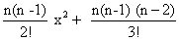x³ +..........+x put x = - 1
0 = 1 - n + 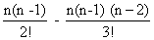+ ..........++ (-1) ^{n} ...................(1)
Now replace n by n - 1
So, 0 = 1 - (n - 1) + 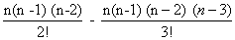+.................+ (- 1) ^{n-1}..............(2)
Multiplying (1) by a and (2) by n and odding we get.
a - na + 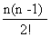a + .................+ (-1)^{n}a + n - n(n -1) +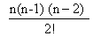- ............+ (-1)^{n-1}n = 0
=> a - n (a-1)+ 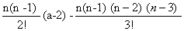-...........+(-1) ^{n}(a-n) = 0....................(3)
Now Replace n by n-1 and a by a-1 in (3) to get
(a - 1) - (n - 1) (a - 2) + (a - 3) + ........+ (-1) ^{n-1} (a - n) = 0......(4)
Multiplying (3) by b and (4) by n we get .
ab - n(a - 1) ^{b} + (a - 2)b +...........+(-1)^{n} (a - n)b
+ n(a - 1) -n (n - 1)(n - 2)+...........+(-1)^{n-1} (a - n)n = 0
On the other hand
(......(((x - 2)² - 2 )² -..........-2)²
= ((......((x - 2)² - 2 )² -........-2)²-2)²
k - 1tirmes
= [ ( R_{k-1}x³ x² + R_{k-1} x + 4) - 2 ]²
= ( R_{k-1}x³ x² + R_{k-1} x + 2)²
= R²_{k-1} x⁶ + 2R_{k-1k-1}x⁵+ (_{k-1}²+ 2p_{k-1}R_{k-1}) x⁴
+ (4R _{k-1} + 2_{k-1}P_{k-1}) x³
+ (P^{k-12} 4_{k-1}) x² + 4P_{k-1}x + 4 .
= [R² _{k-1}x³ + 2R_{k-1k-1} x² + (²_{k-1}+ 2P_{k-1} R_{k-1}) x+4R _{k-1} + 2_{k-1}P_{k-1})] x²
+(P^{k-12} 4_{k-1}) x² + 4P_{k-1}x + 4 .
Whence P_{k} = 4P_{k-1} and _{k}= P²_{k-1}+4 _{k-1}
Since (x - 2)² x² 4x + 4
We have P₁ = - 4.
So, P₂ = - 4², P₃ = - 4³...........
and so, P_{k} = - 4^{k}
NOw let us compute _{k}
= P² _{k-1} +4_{k-1}
=>P² _{k-1} +4(P² _{k-1} +4_{k-2})
P_{k-1}² + 4 (P_{k-2}² + 4 _{k-2})
= P_{k-1}² + 4 P_{k-2}² + 4² P_{k-3}² +.............+4^{k-2}P₁ + 4^{k-1}₁
=> ab - n (a - 1)(b - 1) (a - 2)(b - 2)............+ (-1)^{n}
Or. C₀ ab - C₁(a - 1) (b - 1) + C₂ (a - 2)(b - 2).........
+(- 1)^{n} C_{n} (a - n) b - n) = 0
(3) Determine coefficients in x² appeating parantheses have been removed and like terms have been callected is the expression
(.........(( x - 2)² - 2)² .........-2 )²
Ans Let us first of all determine constant term which is obtained from the expression.
[ (( x - 2)² - 2)² .........-2 ]²
k times
For kthis we put x = 0 i.e it is equal to
(.........((- 2)² - 2)² .........-2 )²
k times
(.........(( 4 - 2)² - 2)² .........-2 )²
(R -1)times
= (......(4 - 2)²-............-2)²
(R - 2) times
=((4 - 2)² - 2)² = (4 - 2)² = 4
Now let us denote ny P_{k} the coe fficient of x by P_{k}the coefficient of x² and the R_{k} the coefficient of x³ the sum of terms involving x to the powers higher than 2 then we can write
(.........(( x - 2)² - 2)² -.........-2 )²= R_{k} x³ + _{k}x² +P_{k}x + 4
Now by substituting img ..........= 1, P₁ = - 4, P₂ =-4².....
into this expression we get,
_{k}= 4^{2k-2} + 4.4^{2k-4}+ 4² 4^{2k-6}+........4^{k-2} 4² + 4^{k-1} 1.
= 4^{2k-2} + 4.4^{2k-3}+ 4² 4^{2k-4}+........4^{k} ++4^{k-1}
= 4^{k-1} [ 1 + 4 + 4² +..........+4^{k-1}]
=4^{k-1} 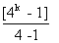
= 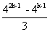
So, Coefficient of x² in the given expression is
Dumb Question. What is the significance of the subscript in R_{k} ,_{k} , P_{k} etc?
Ans One may note that the expression in a very symetric kind of fexpression where things are repeated k times The subscript k denotes that repetition olnly .
One should always remember that symetry isan important thing in matrematics and should be always used aas an important tool
Key words
(1) Binomial theoram
(2) Binomial Coefficient .
(3) General term .
(4) Multinormial theoram.
(5) Binomial series.
(6) Middle term.

